This is the day the Lord has made, let us be glad and rejoice in it.

Thank you Ps Lakers for allowing me to lead with a message today for the men of MAGH.

I pray that the Holy Spirit guides me in thought and action so that no word delivered today falls to the ground IJN amen.

The season that I am in is one of obedience and I am hoping this lasts the rest of my life.

And when I say obedience, it is to my Holy Father and His Will in my life.

In fact, the Word is the only thing I stand on for my life.

God’s message through scripture is the only truth because God does not lie.

Numbers 23:19
God is not a man, that He should lie,
Nor a son of man, that He should repent.
Has He said, and will He not do?
Or has He spoken, and will He not make it good?

God holds His Word to the highest level possible.

Psalm 138:2
I will worship toward Your holy temple,
And praise Your name
For Your lovingkindness and Your truth;
For You have magnified Your word above all Your name.

*** The Blessings That Come From Obedience ***

Throughout scripture we find that when we give God praise, exalt His name and are obedient, He showers us with blessings beyond our imaginations.

There are spiritual and physical components to the bless msg that follow obedience

- Through obedience you grow closer to God and feel His presence as you would a close friend.

- There is an inner peace and a continuous joy no matter the circumstances because you trust the Lord.

- There is a spiritual power that allows you you to make the correct decisions in life because you are led by the Holy Spirit.

- God sends provision to take care of your daily life and work.

- There is a supernatural protection that diverts dangers and trouble when you are under God’s Will.

- Your family is impacted positively as good choices will bring blessings to the ones you love.

Deuteronomy 28:1-7
Now it shall come to pass, if you diligently obey the voice of the LORD your God, to observe carefully all His commandments which I command
you today, that the LORD your God will set you high above all nations of the earth. And all these blessings shall come upon you and overtake you, because you obey the voice of the LORD your God:
“Blessed shall you be in the city, and blessed shall you be in the country.
“Blessed shall be the fruit of your body, the produce of your ground and the increase of your herds, the increase of your cattle and the offspring of your flocks.
“Blessed shall be your basket and your kneading bowl.
“Blessed shall you be when you come in, and blessed shall you be when you go out.
“The LORD will cause your enemies who rise against you to be defeated before your face; they shall come out against you one way and flee before you seven ways.

Gentlemen, in the words of Robert Blake in the US TV show Barretta in the 70’s,

“ You can take that to the bank”

This literally means that the Word is as secure as anything deposited into a bank vault.

Except this is infinitely more secure as God’s promises in His Word comes from Heavenly, divine storehouses, as absolute truth, graced by Him when we submit and obey.

This is the only way a Christian should move in the world we have today. The impossible will only become possible when we obey our Holy Father.

Obedience is favoured by God because He knows we can be trusted to steward the assignments prepared for us.

Yes, these assignments are waiting for us, ordained by God before we were in the womb.

Jeremiah 1:5
Before I formed you in the womb I knew you;
Before you were born I sanctified you;
I ordained you a prophet to the nations.”

Imagine that, the perfect path has been set for us, only when we submit and obey.

Find that secret place dear men of MAGH. It is where our Father is waiting to whisper His instructions along with His Holy assurances and promises through His Word.

I implore everyone on this platform to simply love God because He is our Holy Creator and we are graced with every breath because of Him.

God’s love for us is so great that he gave His only son to the world as a living sacrifice for our salvation.

Who here can even imagine making that sacrifice of his own children.

Through Jesus Christ we are redeemed and sanctified, set apart from all who do not profess that He is our Saviour.

We should give thanks and praise only that our Holy Father hears us and be pleased. Submit to us and God will hear us.

2 Chronicles 7:13-15
When I shut up heaven and there is no rain, or command the locusts to devour the land, or send pestilence among My people, if My people who are called by My name will humble themselves, and pray and seek My face, and turn from their wicked ways, then I will hear from heaven, and will forgive their sin and heal their land. Now My eyes will be open and My ears attentive to prayer made in this place.

*** The Rewards Of Obedience ***

- A long Life

Deuteronomy 4:40
You shall therefore keep His statutes and His commandments which I command you today, that it may go well with you and with your children after you, and that you may prolong your days in the land which the LORD your God is giving you for all time.”

Moses reminds the people of Israel to follow the laws of God that they and their families should thrive.

This is a good reminder for us too that we should obey the Word of God so that our children’s children shall also be blessed with long and fruitful lives.

Also in,

Deuteronomy 5:33
You shall walk in all the ways which the LORD your God has commanded you, that you may live and that it may be well with you, and that you may prolong your days in the land which you shall possess.

Proverbs 3:1-2
My son, do not forget my law,
But let your heart keep my commands;
For length of days and long life
And peace they will add to you.

Proverbs 10:27
The fear of the LORD prolongs days,

Psalm 91:16
With long life I will satisfy him,
And show him My salvation.”

- Unexpected Favour

Throughout scripture there is evidence of unexpected favour to those obedient to God. These are often during times of hardship.

So brothers, whatever you are facing today, be expectant of a miracle to appear and hold that close to your heart.

God is waiting for the moment of complete submission and obedience to show His majesty through His blessings.

Genesis 39:21-23
But the LORD was with Joseph and showed him mercy, and He gave him favor in the sight of the keeper of the prison. And the keeper of the prison committed to Joseph’s hand all the prisoners who were in the prison; whatever they did there, it was his doing. The keeper of the prison did not look into anything that was under Joseph’s authority, because the LORD was with him; and whatever he did, the LORD made it prosper.

Exodus 3:21
And I will give this people favor in the sight of the Egyptians; and it shall be, when you go, that you shall not go empty-handed.

Psalm 5:11-12
But let all those rejoice who put their trust in You;
Let them ever shout for joy, because You defend them;
Let those also who love Your name
Be joyful in You.
For You, O LORD, will bless the righteous;
With favor You will surround him as with a shield.

- Power And Authority

Power and authority flow directly from God’s divine realm when we are fully submitted and obedient.

When we are under divine authority, then we can claim that all power is legitimate as it is graced to us by God.

Romans 13:1
Let every soul be subject to the governing authorities. For there is no authority except from God, and the authorities that exist are appointed by God.

1 Samuel 15:22
So Samuel said:
“Has the LORD as great delight in burnt offerings and sacrifices,
As in obeying the voice of the LORD?
Behold, to obey is better than sacrifice,
And to heed than the fat of rams.

James 4:7
Therefore submit to God. Resist the devil and he will flee from you

James 4:10
Humble yourselves in the sight of the Lord, and He will lift you up.

- Blessings And Multiplication

Genesis 22:16-18
and said: “By Myself I have sworn, says the LORD, because you have done this thing, and have not withheld your son, your only son— blessing I will bless you, and multiplying I will multiply your descendants as the stars of the heaven and as the sand which is on the seashore; and your descendants shall possess the gate of their enemies. In your seed all the nations of the earth shall be blessed, because you have obeyed My voice.”

Because of Abraham’s obedience to God’s request to sacrifice his son, the Lord bestowed blessings and multiplications beyond the imagination.

Our Lord is waiting for each and everyone of us to obey Him through submission to His Will for our lives.

The blessings will be so great that they will overflow beyond our capacity to handle them and we in turn will bless others.

This is the promise of our awesome God and we do well to follow the path He set for us before we were known.

IJN amen.

- Testimony Of Obedience

Meditate on the message shared by Ps Lakers

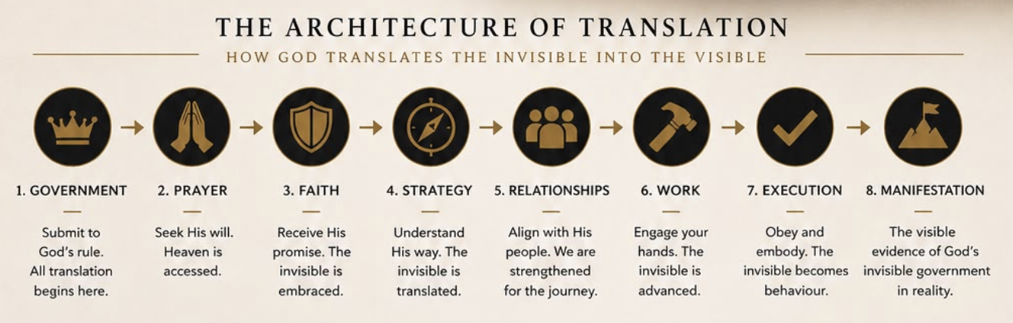

Ps Lakers.

